IRA FUNDAMENTALS AND HANDS-ON PRACTICE – SHOPEASY PROJECT

Introduction to Jira
  - What is Jira?
Jira is a project management tool used by software development teams to plan, track, and manage their work.
It helps teams organize tasks, track project progress, manage bugs, and complete work efficiently.

Why Jira is Used
Jira helps teams to:
    - Manage project tasks.
    - Track development progress.
    - Organize requirements.
    - Identify and track bugs.
    - Plan and manage sprints.
    - Improve team collaboration.

Understanding Agile Methodology
  - What is Agile?
Agile is a software development methodology in which a project is divided into smaller parts and developed step by step.
Teams work in short cycles called Sprints and continuously improve the product.

Scrum Framework
Scrum is an Agile framework used to manage project work. Important Scrum concepts:
    - Product Backlog
    - Sprint
    - Sprint Planning
    - Daily Scrum
    - Sprint Review

    - Sprint Retrospective

Creating a Scrum Project
Created a Scrum project in Jira for the ShopEasy project.

Project Details:
- Project Name: ShopEasy
- Project Type: Scrum
- Project Purpose: To organize and manage project activities using Agile methodology. Learned how to create a project and understand the Jira project interface.
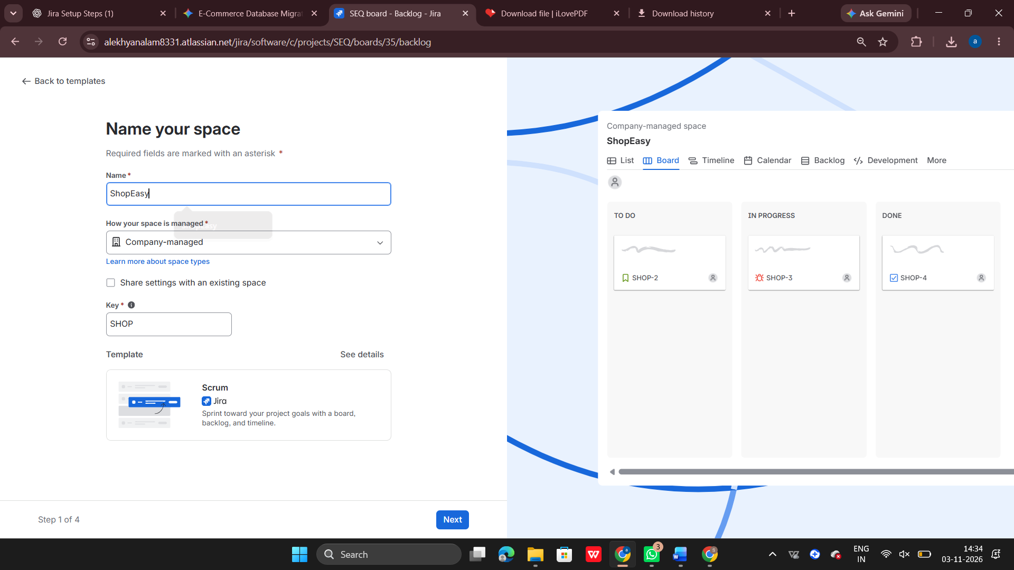

Understanding Epics
  - What is an Epic?
An Epic is a large piece of work that can be divided into smaller User Stories.

Creating Epics
Created and explored Epics to organize the major functionalities of the ShopEasy project. Examples of possible e-commerce modules:
    - User Management
    - Product Management
    - Shopping Cart
    - Order Management
    - Payment Management
Epics help organize related requirements under one major functionality
.
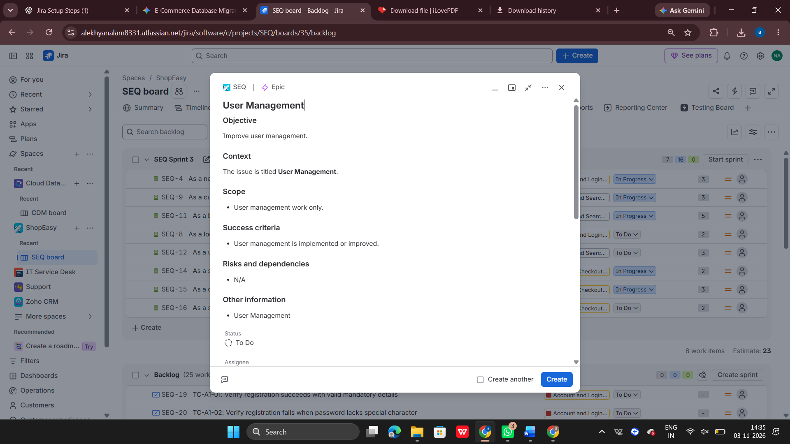

Creating User Stories
  - What is a User Story?
A User Story describes a feature from the user's point of view.

User Story Format:
As a user, I want to perform an action so that I can achieve a benefit.

User Stories in ShopEasy
Worked with User Stories to understand how project requirements are divided into smaller tasks.
Examples:

    - As a user, I want to register an account.
    - As a user, I want to log in to my account.
    - As a user, I want to view available products.
    - As a user, I want to add products to my cart.
    - As a user, I want to place an order.

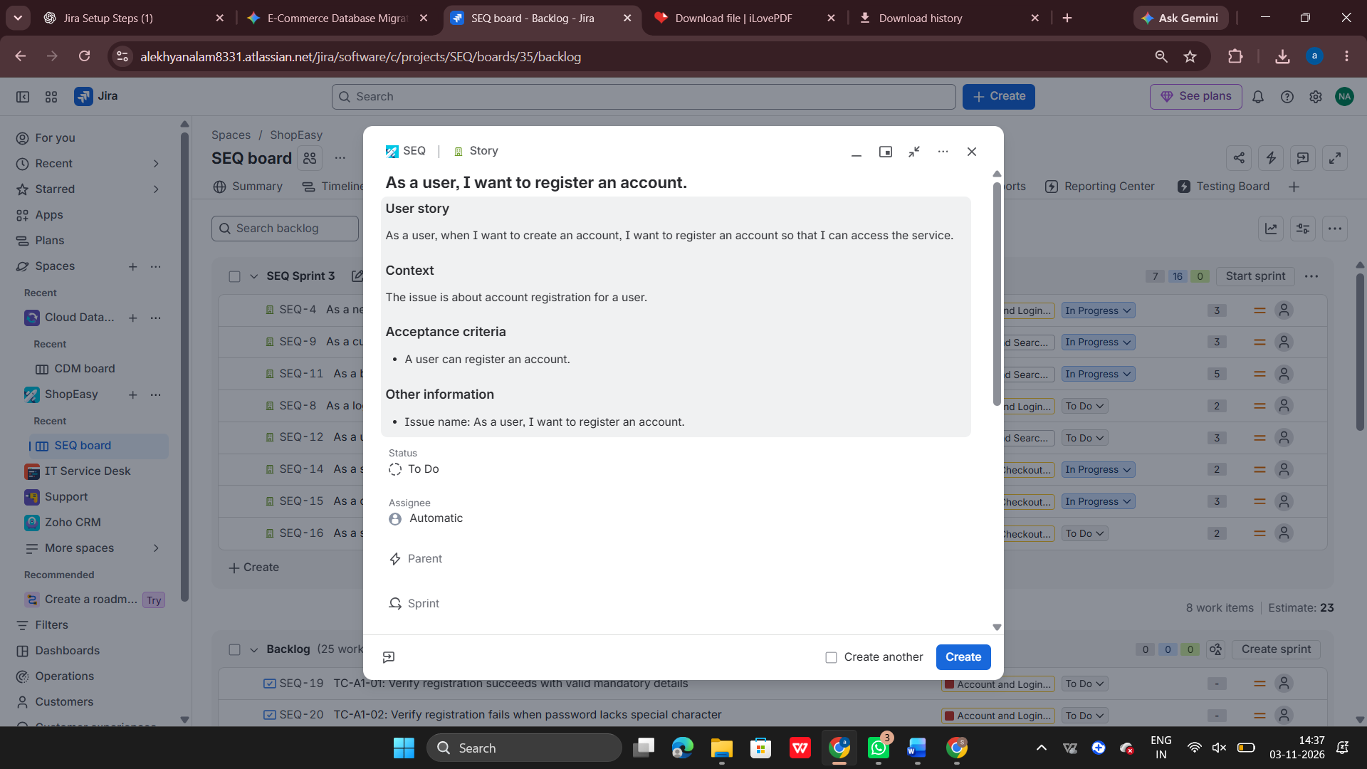5.3 Acceptance Criteria
Acceptance Criteria define the conditions that must be satisfied for a User Story to be completed.
They help developers and testers understand the expected functionality.

Understanding Jira Work Types
Learned about different work types used in Jira.
- Epic: A large functionality or requirement.
- Story: A feature requested by the user.
- Task: A specific piece of work.
- Bug: An issue or defect in the application.
- Sub-task: A smaller activity created under a parent task.
- Test: Used to represent a test case when supported by the testing setup. These work types help teams organize and track project activities.

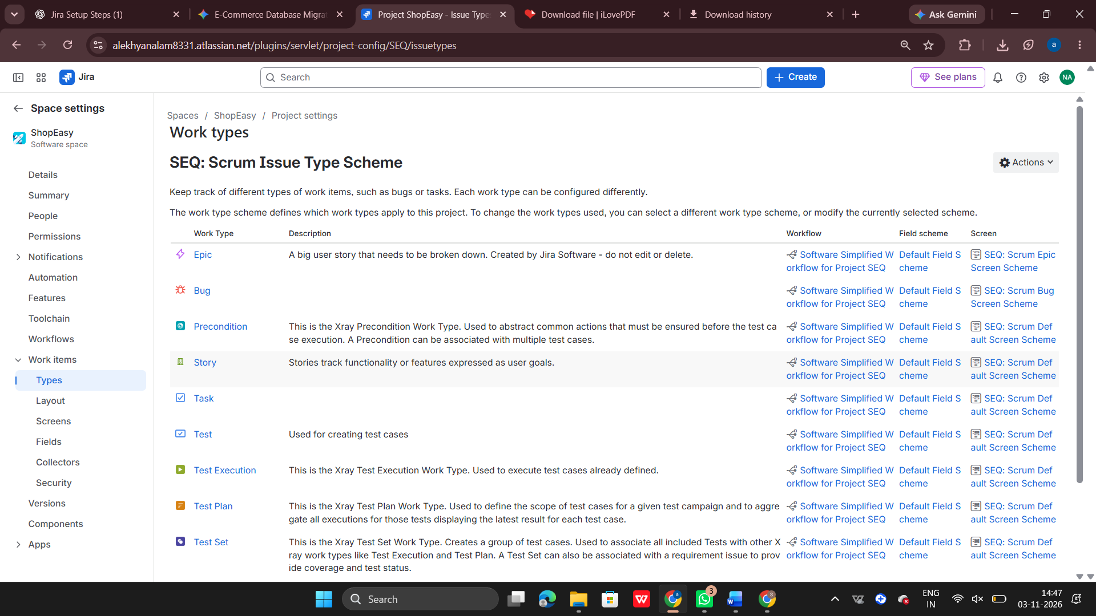

Understanding Workflow
  - What is a Workflow?
A Workflow represents the different stages through which a Jira issue moves until it is completed.

Common Workflow Statuses
    - Open: The task is newly created.
    - To Do: The task is waiting to be started.
    - In Progress: The task is currently being worked on.
    - Done: The task has been completed.
Learned how issues move between different statuses during project development.

Understanding Test Cases
A Test Case contains steps used to verify whether a particular functionality works correctly.
Learned how test cases are related to application requirements and how testing helps identify defects.
Test cases help ensure that the application works as expected.

Bug Reporting and Defect Management
  - What is a Bug?
A Bug is an error or defect in an application that causes it to behave differently from the expected result.

Creating and Linking Bugs
Learned how to create a Bug in Jira and understand how it can be linked to the related Story or testing activity.
A Bug generally contains:
    - Bug Summary
    - Description
    - Steps to Reproduce
    - Expected Result
    - Actual Result
    - Priority
    - Environment

Bug Workflow
Understood the common bug lifecycle:
- Open
- In Progress
- Fixed
- Retest
- Closed
This process helps the team track defects until they are resolved.
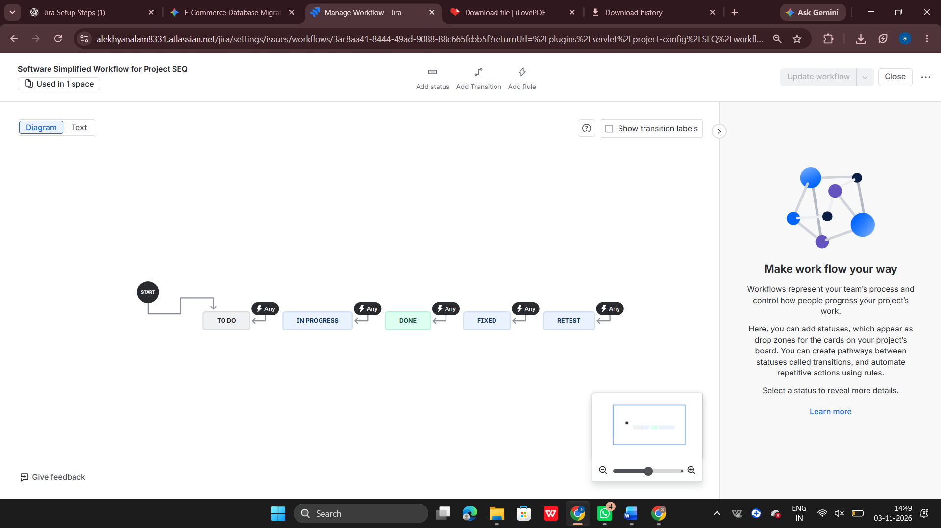

Understanding Test Plans
A Test Plan is used to organize testing activities for a project or release.
Learned how test plans help the testing team organize test cases and track testing progress.

Jira Dashboards
A Dashboard provides a summary of project information in one place.
Learned how dashboards help teams view project progress, task status, and other important project information.
They make it easier to monitor project activities.
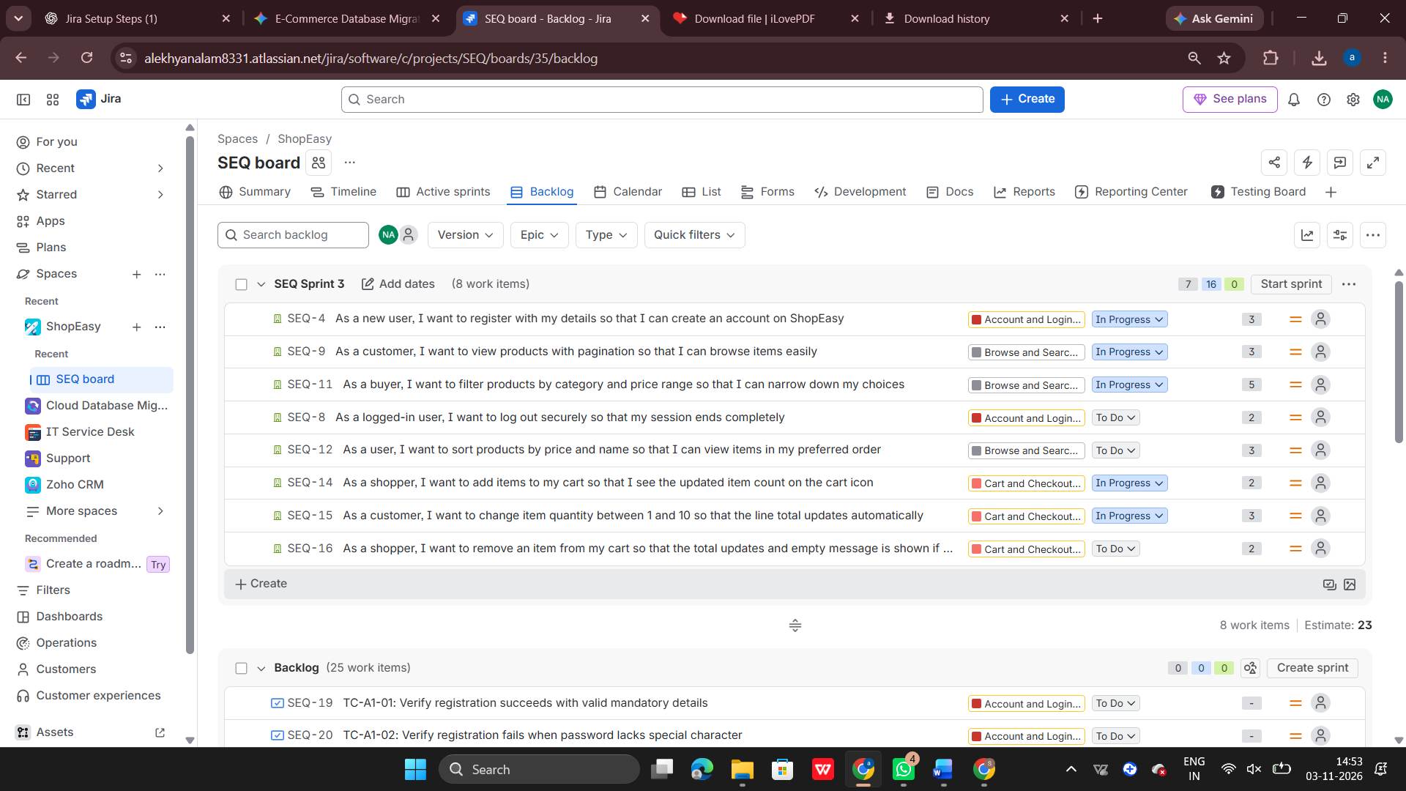

Understanding JQL Filters
JQL stands for Jira Query Language.
It is used to search and filter Jira issues based on specific conditions.
Learned how JQL helps find issues using details such as project, issue type, status, and assignee.
Example:
project = ShopEasy AND status = "In Progress"
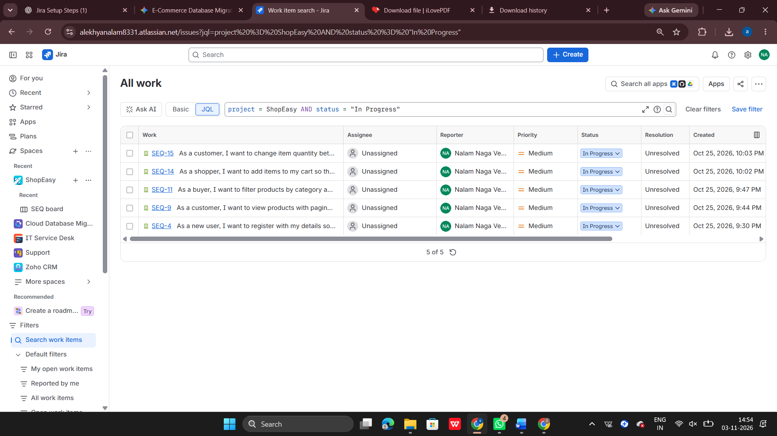
This query helps find issues in the ShopEasy project that are currently in progress.

Hands-On Practice and Learning
During the practical session, I learned about:
- Creating a Scrum project in Jira.
- Understanding the Jira project interface.
- Creating and organizing Epics.
- Creating User Stories with Acceptance Criteria.
- Understanding different Jira Work Types.
- Exploring Jira Workflows.
- Understanding Sprint Planning and Sprint Backlog.
- Learning Story Points and estimation.
- Understanding Test Cases and Test Plans.
- Creating and tracking Bugs.
- Understanding Bug Life Cycle.
- Exploring Jira Dashboards.
- Learning basic JQL filters.

Complete Jira Workflow
Learned the overall project management flow using Jira:
- Create a Scrum Project.
- Create Epics.
- Create User Stories.
- Add Acceptance Criteria.
- Organize work using Jira Work Types.
- Plan Sprints.
- Estimate work using Story Points.
- Track tasks through Workflows.
- Understand Test Cases and Test Plans.
- Report and track Bugs.
- Monitor progress using Dashboards and JQL.

Conclusion
Through this practical training, I gained knowledge of Jira and Agile project management using the ShopEasy project.
I learned how to create and organize project requirements using Epics and User Stories, understand different Work Types, manage Sprints, track Bugs, and monitor project progress.
This hands-on practice helped me understand how Jira is used to manage software development activities in a real-time project Environment.

